How to export and import data
For Export data
Login in system user

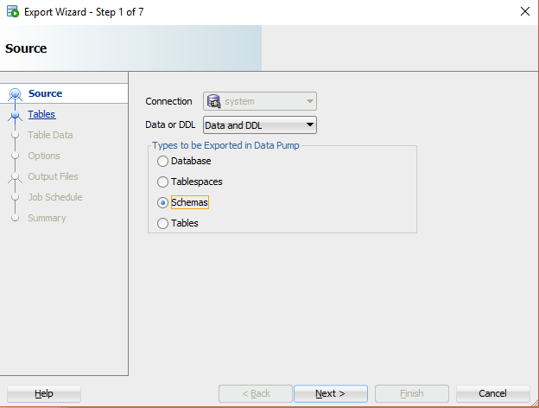
Select option database/tablespaces/schemas/tables

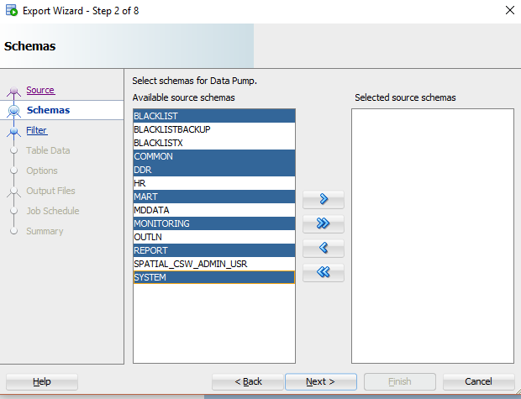
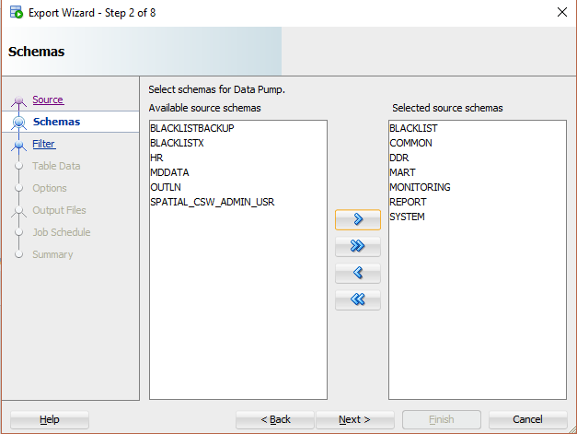
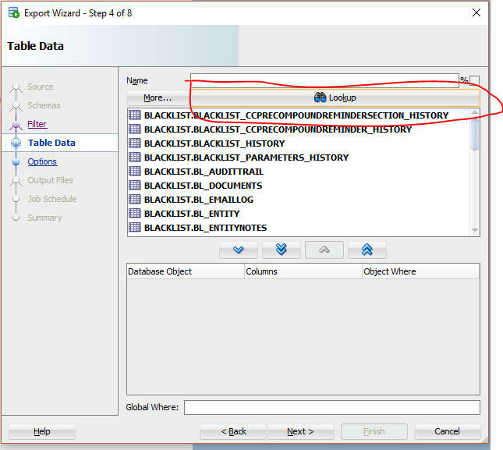
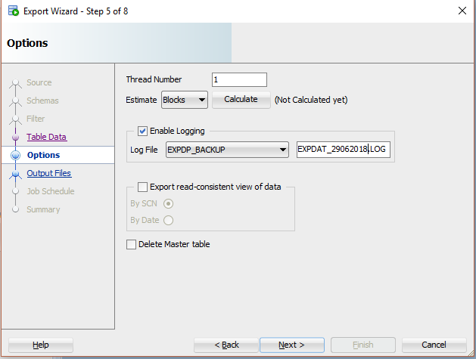
Select option
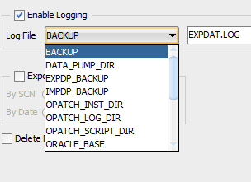

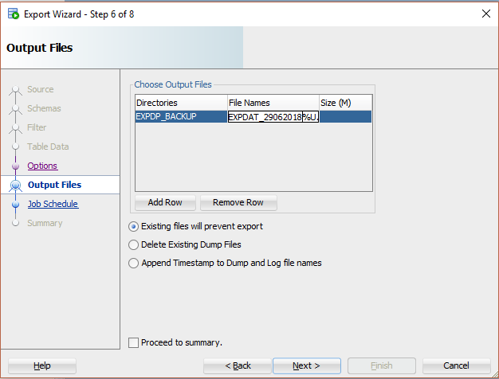
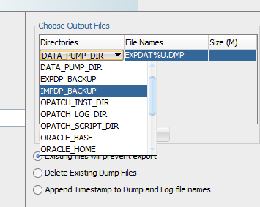
Select filename as EXPDATALL%U.DMP
Check the file path in unix
/u01/app/oracle/admin/ssmdb/dpdump/
Two file created
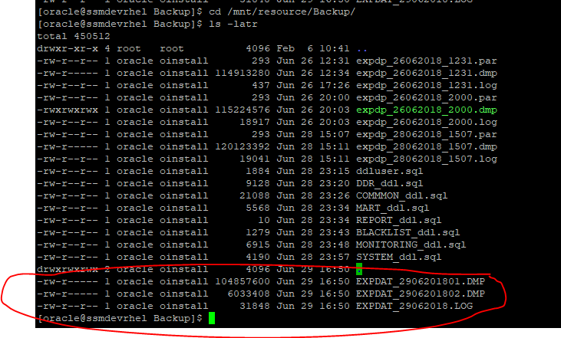
select DIRECTORY_NAME,DIRECTORY_PATH from dba_directories;
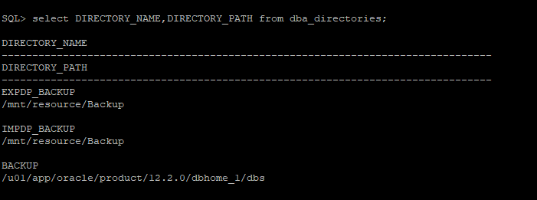
SELECT owner_name, job_name, operation, job_mode,state, attached_sessions FROM dba_datapump_jobs ORDER BY 1,2;
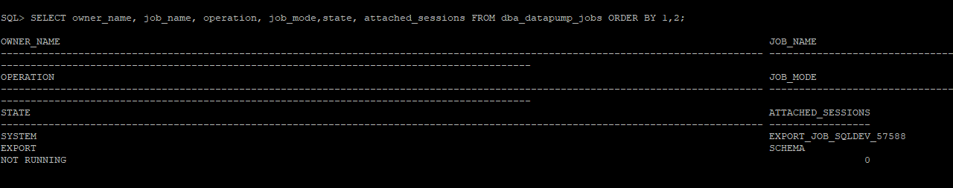
IMPORT data
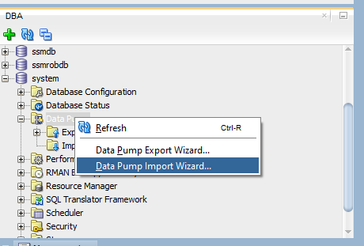

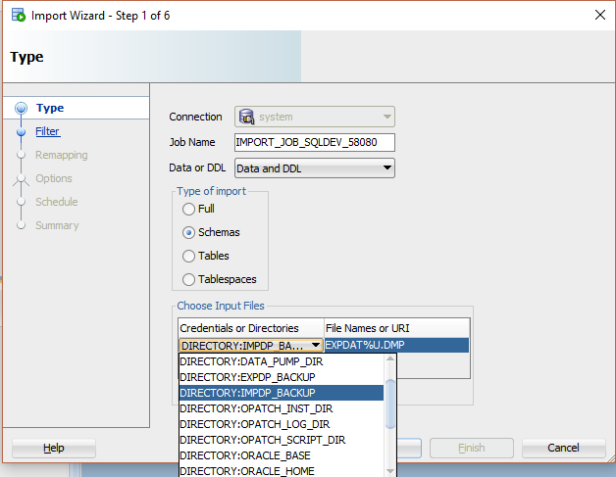

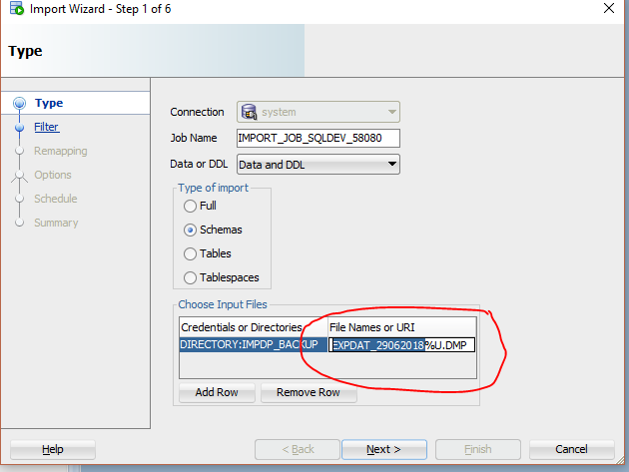
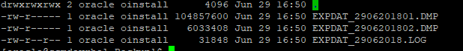

If dump created in two files like EXPDAT_2906201801.DMP/EXPDAT2906201802.DMP. Give only the file name as EXPDAT_29062018
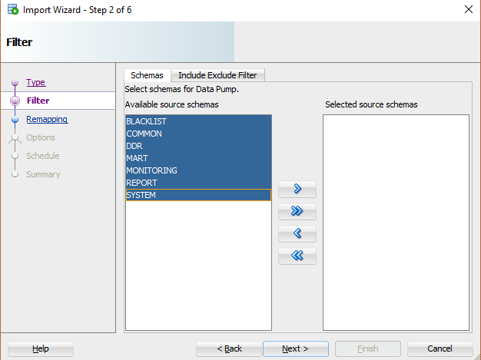.
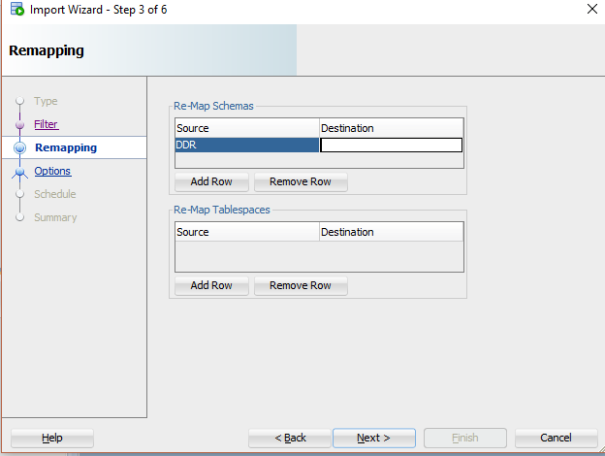
Add row and select source and destination.
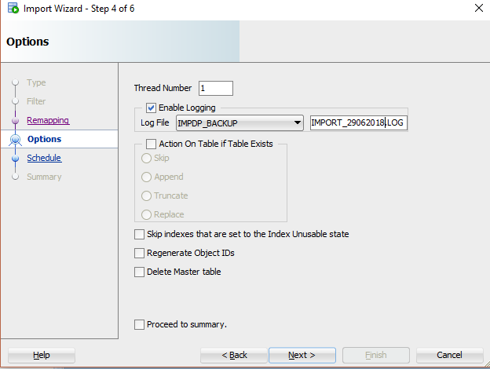
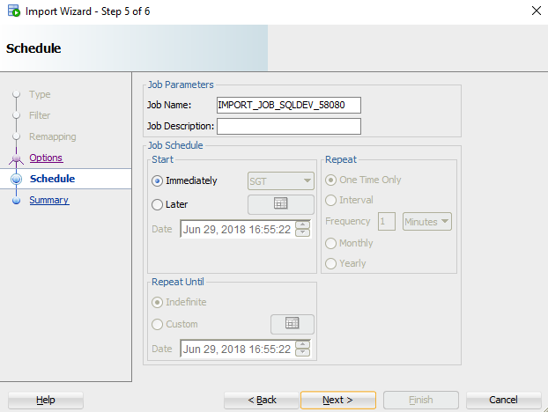
Click on next.....

